20 Questions
Questions:
1. Please tell us about yourself, what is/was your career, about your family etc.

I've been making high end reproduction and historically inspired furniture for 40 years. After graduating from Haverford College (in PA) with majors in music & biology, I thought I wanted to get a doctorate in molecular biology. After the first 12 rather miserable months spent with test tubes in the lab, I learned a lot about myself. Firstly, I needed to be a generalist academically. Secondly, having been a tinkerer, growing as a musician, and possessing an artistic bent since toddlerhood, I realized that I absolutely needed to work creatively with my hands. I had a very strong sense that I wanted to work with wood and not any other media. So I took off a few years, worked at my dad's tree nursery hoeing fields and digging trees and worked on my brother’s landscape crew. At that time, in the early 1980’s. there was very little formal opportunity to learn woodworking on a hands-on level. There was almost nothing available in the way of classes. Having minimal funds, I wrote letters to furniture makers throughout the US enquiring about working as an apprentice. No one would take me.

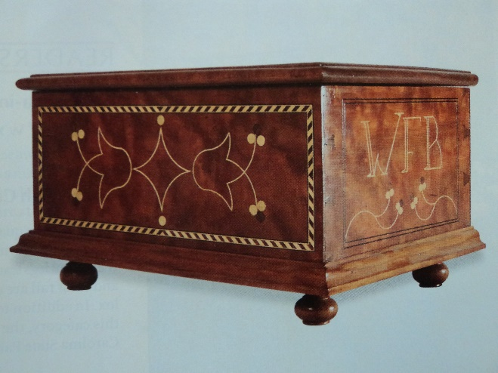

However, I was very fortunate in convincing ("begging" is more accurate) a local Pennsylvania cabinetmaker, E. Townsend Moore, to let me into his shop. He had been a curator at Dupont’s Wintertur, outside Wilmington, DE, and had learned from a long line of Chester County period furniture makers. His mentor was Thomas Treate Hogg, a well known Chester County reproduction period furniture maker in the 1940's- 60's. I worked 60 hour weeks as a landscaper but was at Townie Moore’s shop near Media, PA every weekend. Because he saw the seriousness of my interest and he also did not have anyone to pass his skill on to, he really took me under his wing and gave me a lot of time. In return, as I had no money to offer, I did a very thorough cleaning of his shop after every work session, which he was quite grateful for. Moore was an extremely generous and patient teacher and I was an eager student who learned fast. After about a year, I was pretty much able to look at any photo of a period furniture piece and make what I saw.

I considered becoming a cabinetmaker as a career, so I spent time interviewing furniture makers around Chester County. What I found was that many professionals were just not all that happy. Making a living as an artisan is very hard work and many of the folks were not doing what they really wanted to so, but were instead fixing broken chairs and repairing shabby Victorian dressers. While I was out hoeing the fields in the hot sun at work one day, I decided that I'd apply to medical school and gain a more secure career, while pursuing furniture making on the side any way I could. I had a strong background in biology and chemistry at Haverford, and was already doing volunteer work with brain injured patients at the Bryn Mawr Rehab facility in Malvern, PA.

Well, it took many years and about 10 different shops to get things going. I have memories of using one of those toxic fume-spewing ‘Ready Heaters ‘ in my sub-zero garage in Watertown (far upstate) NY. It was so cold I had to wear gloves in the shop for many years.
To cut the story short, I went on to become an anesthesiologist and continued to be a passionate student of period furniture making. I just used every opportunity to gain more skills and kept learning more about woodworking through the years. Over 35 years I slowly acquired a full shop of third-hand tools. My passion for furniture making and carving has only increased over the years.

2. How did you get started doing woodwork and how long have you been a
woodworker?

See above

3. What was the first item you ever made and which is your favourite piece?

First piece was a walnut Kentucky end table I made with Townie Moore as an apprentice in 1981. He wanted me to do some turning right off the bat. The piece involved most of the basic joinery required for any further furniture project. The drawer was cock-beaded. I added the inlay more recently.

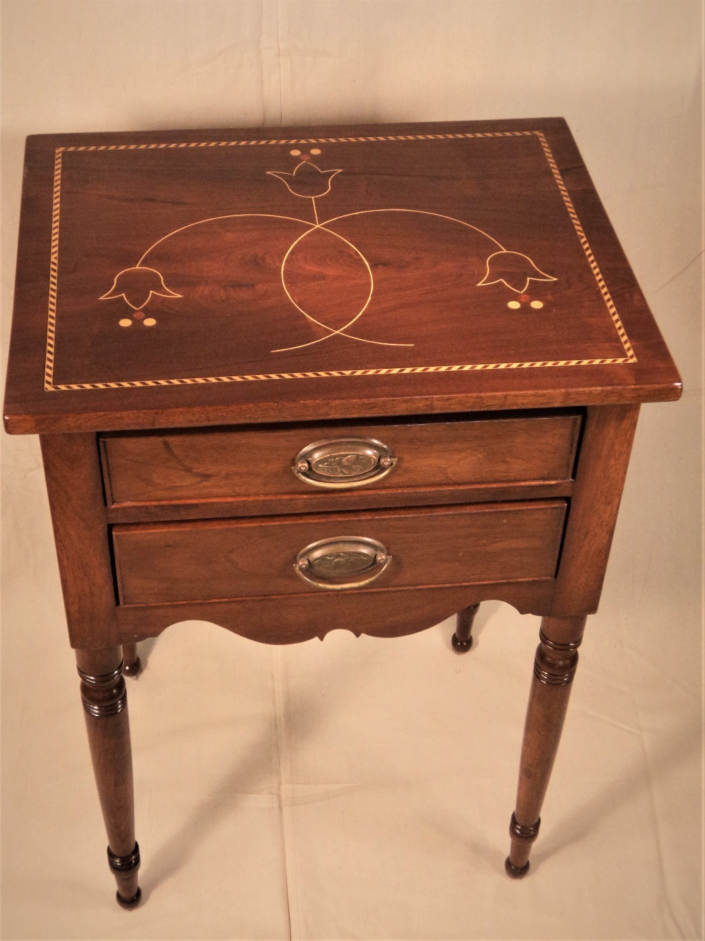

My favourite piece:
Not sure but my wife likes my ‘Alton Hall serpentine chest of drawers’ best…..

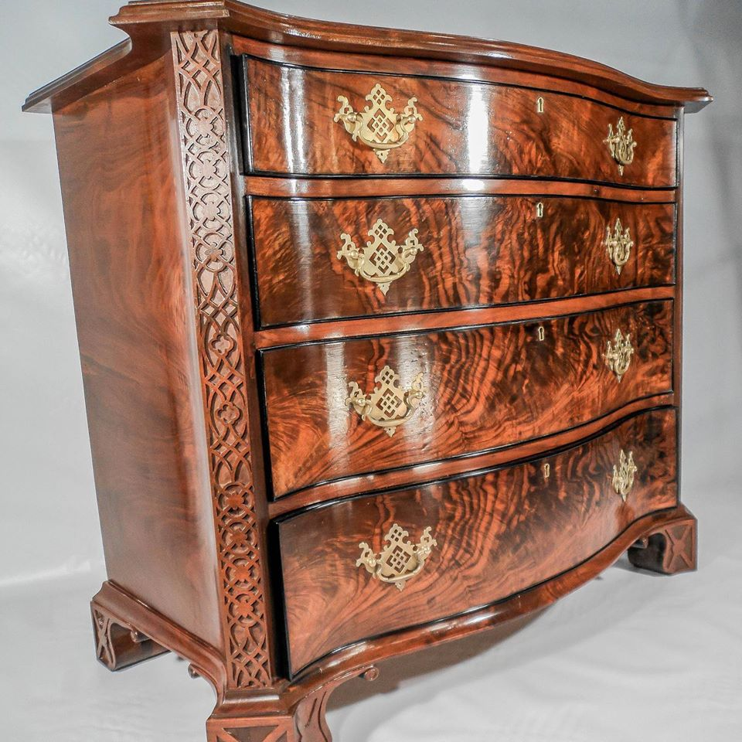

I wrote an article in last edition of “Period Furniture”, the annual journal of the Society of American Period Furniture Makers (SAPFM) on how to make the veneered serpentine drawers for this chest….
American Period Furniture (sapfm.org)

4. Which styles of furniture do you enjoy building the most?

I prefer to make 'historically informed' pieces. Unless requested by a museum, my furniture is not an exact reproduction, but will incorporate design motifs and joinery that is representative of 18th and 19th century furniture. My work is made using similar hand-cut joinery and detail, but each piece is my own design. Except for my museum & historic site reproductions where exact copies are desired, my furniture is one of kind, based on traditional design elements.
I like the William and Mary period furniture a lot and incorporate ball feet in many of my projects, even contemporary ones. I have been doing a lot of veneer and inlay the last 4 or 5 years with my Federal furniture. I enjoy carving and so Chippendale pieces are an interest as are Queen Anne. I also like Shaker furniture and hope to do some more of that in the future. Most of my pieces are historically informed but my own design.

5. Which are your favoured local timbers and which are your favoured exotic
timbers to work with?

I work mostly with local hardwoods: walnut, cherry, maple, pine, poplar. I really like figured varieties for my work and am always looking for curly maple, walnut, and cherry. My Bellamy eagle carvings (Bellamy Eagles | William Francis Brown | Line And Berry |Camden, Maine) are mostly in pine, and occasionally basswood. I use a lot of holly, another local hardwood, for inlay. It is the whitest of woods and contrasts nicely with walnut in particular. Cedar is local and is used for the berries in my Line-and-berry inlay.

I use a lot of exotics. Paduak when I want a reddish wood, Katalox is my ebony substitute. I do like Macassar Ebony and Ribbon stripe Mahogany for cross banding. I use many others for bandings and inlay.

6. Please list your most used hand tools and tell us why they are your “go to”
tools? (at least 5)

I mainly use just a few planes. The Lie-Nielson brass block plane and their 62 low angle jack plane handle almost everything. I do use a shoulder plane and a scrub plane at times as well. Marples Blue Chip are fine for my chisels.
I have a Veritas dovetail saw and a Florip saw. I use the lie-Neilson radius cutter a lot for my inlay work. It’s a beautiful tool designed by my friend Steve Latta. I guess I am too cheap to buy many high end tools. I keep mine sharp and they do the job very well.
I do not like tool cabinets. My tool collection is fairly minimalist and I like to keep everything out and within quick reach. My marking tools are all hanging on my bench.

7. Can you list your favourite power tools and machines and tell us why? (At least
5)

No real favourites. I have the basic set: 8 inch General jointer (would love to have a 12 inch, but not sure how it would fit in my small shop). I did install a Byrd Shelix helical cutter which I love. 15 inch Grizzly planer with helical cutterhead; Grizzly tablesaw; General drill press. As a thrifty Scot, most of my tools are used. I often wish I had a wide belt sander, but, again lack the space.

8. What is it about working with wood that you find most enjoyable?

I like to scour museum archives and study originals for ideas, patterns, moldings, inlay designs, & proportions. I enjoy sketching details of the Chester County pieces I see in homes and exhibits in my home area. I think that with time one develops a trained eye. Craft is a combination of knowledge, skill and intuition all working together. It takes time and work to gain this, but it's fun. A passion for excellence and beauty is why I love to make furniture.

9. What type of workshop do you have: standalone / garage / basement etc. What
floor size is your shop? Can you tell us about how your workshop has evolved
over time and why, and what is the layout/workflow that you have developed?
(workbenches/assembly benches/lighting/dust extraction/timber storage/tool
storage)

I have 2 workshops: my shop in VA is a 25’ x 30’ basement shop and a “real” working shop where all my furniture is made. My 28’ x 28’ brand new shop in Camden, Maine is more of a “boutique” shop where my Maine Coast Workshop classes will be held. The Maine shop is all about comfort and aesthetics:

From my school website: The shop | Maine Coast Workshop

The Maine Coast Workshop is an intimate space featuring:

​
- 6 student benches with 2 vises each, and a master instructor's bench
- Student hand tool and carving sets
- Full slate of power tools including 8" jointer, 15" planer. We focus on safety!
- Library of woodworking, carving, and traditional arts books & videos
- Plenty of info on local eats, places to visits, beaches, and things for family to do
- Coffee & beverages
- Pine floors are easy on the feet
- Lots of natural light
- 3 blocks from the Camden Harbour

The VA shop has evolved over 35 years – I still have many of the original tools that I have dragged around the country with various moves. Everything was in storage for about many of those years in Mechanicsville, VA. But you are right, a shop certainly does evolve. Fine-tuning and tweaking is an ongoing process, always making it more efficient and user friendly. I don’t think a month goes by where I don’t make some sort of alteration. My power tools naturally are on one side and my bench on the other. 90% of my time is at the bench. I like a lot of tables, and have modified a large desk that I pulled out of a dumpster, an old lab table I got at an auction in upstate NY, etc. Everything in my shop is on wheels. My primary bench was a $20 Craigslist find which I have souped up and added to.

Here’s a video of the shop made by Joshua Farnsworth at “Wood & Shop”… 10 Jaw-Dropping Woodworking Shop Tours | Wood and Shop

https://youtu.be/qtWfoi1VBXo

Also, see 2nd & 3rd videos: Workshop & Tours | Wood and Shop

10. What is your clamp line-up and why?

I love the Highland Hardware Quick Grip clamps. They are rugged and I use them for everything. I found some wonderful Stanly heavy clamps at Harbour Freight which they no longer seem to carry. For larger glue-ups I have the usual ½ and ¾” pipe clamps with Jorgenson type fixtures. And a large quantity of HF small clamps which work fine and are super cheap. Most of my work is smaller pieces, so I don’t need a lot of massive clamps.

11. What adhesives and glues do you use and why?

Yellow glue. White glue for windsor chairs and when I want a longer set-up time. Cold Press for veneer. Cyanoacrylate for small repairs.
I have a glue pot but just have not caught on to hot hide glue. I played with it a few times and probably have not given it the full college try yet.

12. What woods (exotic and local) have you not yet used and why are you
interested in building with them?

See #5 above. I really like spalted maple, but just have not done anything with it yet. It would be nice for my ‘Tree of Life’ keeping boxes….

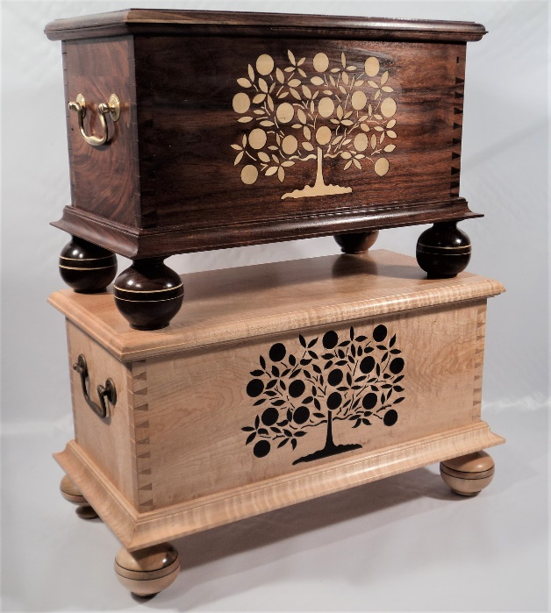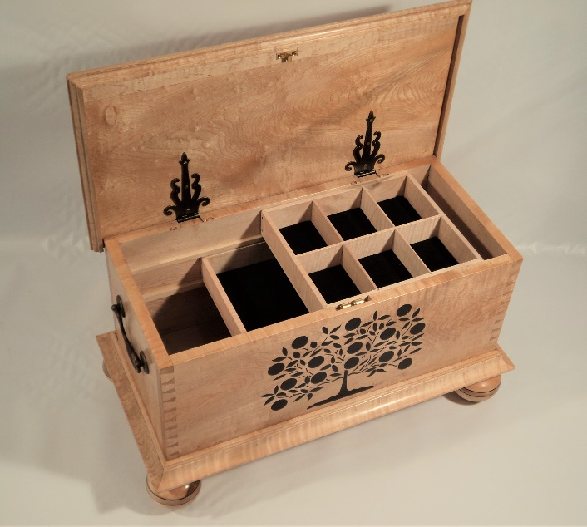

13. What and whom are your sources of inspiration for your woodwork?

Chuck Bender, Glen Huey, Steve Latta. And the 18th century Chester County furniture makers.

14. How do you design your pieces? Do you use CAD or Sketchup? Do you sketch
out by hand etc?

I look at photos everywhere and anywhere. I take photos at museums and historic sites. I am more an artist than engineer. I do not make plans. Typically, I start with a sketch to get proportions looking good, and then just start milling the wood. I will make little sketches as I go for details, moldings, etc. I keep a file for each project with my notes and sketches. I tired working with plans made up by others and find it confusing and difficult.

15. What are your finishing regimes, what products do you use and what are your
favourite processes?

Oil and shellac for almost every project. Since I work with beautiful figured woods I rarely add colour. And if I have used inlay, especially holly, I so not want to obscure or yellow it with dyes or other colouring agents. I use boiled linseed oil followed by shellac most commonly. BLO darkens walnut a lot, but this does create a striking contrast with holly inlay. I use Zinser Sealcoat if I want a perfectly clear chatoyance, or will add varying amounts of “clear” or amber to get the patina I want. After curing I usually rub out the shellac with 4-0 , then 6-0 steel wool and Rennaissance Wax which is my favourite because of its high carnauba content.

16. Which parts of working wood do you dislike the most?

I like it all. I don’t really do that much sanding so will not be able to give the stock reply here

17. What is your favourite music to listen to in your workshop?

I am a guitarist with my own YouTube channel. I like folk, Celtic, Leo Kottke and John Fahey style guitar, classical, and 60-70’s British Rock (Genesis, ELP, Yes, Tull, etc.). I listen to podcasts as well – history, political, Bible and sermons, audio books – going through CS Lewis & GK Chesterton now.

18. What is your tool sharpening regime?

I really hardly ever sharpen. 99% of my tool touch-up is done with a honing machine that I made, and will be marketing soon. I developed this as a natural evolution to keep my carving tools sharp. It’s MDF wheels impregnated with a compound that I make myself from tallow and chromium oxide. I shape the wheels to accommodate various carving tools and mount them on a buffing machine arbour.
All I need to do is tough the edge to the wheel for a second and I’m good to go. When a chisel or plane blade starts to drag, I touch it to the spinning wheel. With this process I do not need to go to a stone for years. And if I do, it will be to the 4000 or 8000 only for a few strokes.
I also keep a horse butt leather honing strip on my bench and make a few passes when needed.

Of course if an edge is nicked or in really bad shape, I’ll go to a grinding wheel and go through the diamond or waterstone grits to sharpen it. I do all that free hand. I have read about and tried every sharpening method known to man. This can be so confusing for woodworkers. Now I just don’t think about it.

19. What custom jigs or tools have you developed for your woodworking?

I have all kinds of custom tools and jigs. I am always thinking of ways to make my processes easier, faster, and safer. I found that cutting the sole off of roller blades makes a wonderful steady rest for turning thin parts, such as windsor chair spindles. I mentioned my honing machine which I will sell on my website stores when I get them set up online (www.MaineCoastWorkshop.com and (www.LineAndBerry.com).

20. What is the next piece you are going to build and why?

I have another Bellamy eagle commission going right now as well as an order for a Thos. Jefferson lap desk going to an antiquarian bookseller in Alexandria. I often make duplicates that I add to my website for sale. I am also making a number of piece on spec that will go to galleries.
I prefer to incorporate new techniques and learn new skills with each new sec piece I make. I enjoy the challenge of pushing myself out of my comfort zone and learning new things. For example, I recently completed two Southern Cellarettes. For a long time I had an idea floating around in my head for making bold striped moldings. I did not know how I was going to do this, but had a clear picture of what I wanted to do. So, I just plow in and figure out a way. I sometimes have to learn the hard way through various dead ends but usually finally come upon a good way to make it work…..

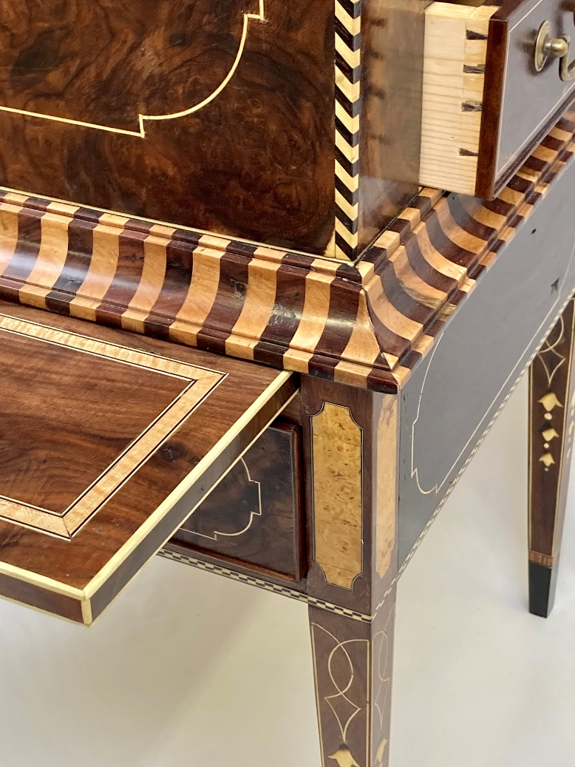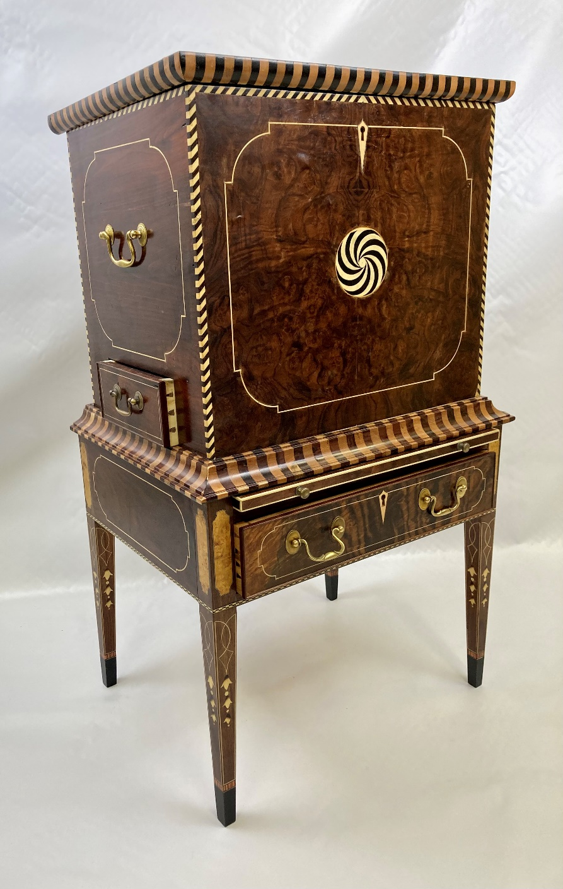

I have wanted to make the Walker tea table featured at MESDA for some time. I love the carving in that piece.

Tool Wishlist:
Please list five or more hand tools/power tools or machine tools.

Any high-end small maker hand tools, especially planes. Anything by Lie-Nielson. There are a number of small outfits now making incredible tools. I love to use these but it’s a stretch to afford them myself.
I could really benefit from a 12 inch jointer and 20 inch planer.

Timber Wishlist:
Please list five or more local and five or more exotic timbers that you have not yet worked
with and would love to try.

Wish I had a stash of Cuban Mahogany!

List of makers and their woodshops that you would love to spend time with:

Andrew Crawford, UK boxmaker.
Frank Strazza – to make a workbench.
Chuck Bender – to make a Philadelphia Highboy
Ray Journigan- ditto, or any highly carved Chippendale piece
Alf Sharp – making a highboy with lots of carving

